|  |  |
| --- | --- |
| ***This app is for testing purposes only***. Use this app to test if your device is properly configured with Wifi and the App Inventor companion. If your device is properly configured, then using the App Inventor companion to scan the barcode should result in the app opening on your device.    **CSP Learning Objectives:**   * *Creativity: 1.1.1 - The student can use computing tools and techniques to create an artifact. [P2]* |  |

## 

## 

# Getting Ready

1. Open [App Inventor 2](http://ai2.appinventor.mit.edu/).
2. Go to *Project*
3. Select *Import Project (.aia) from an online repository.* A window like the one shown below will appear. **NOTE:** This screenshot is included to give you a general sense of how the *Upload Template* window will look each time you open a new template. The screenshot you see will not always reflect the name of and picture for the template you are asked to select.

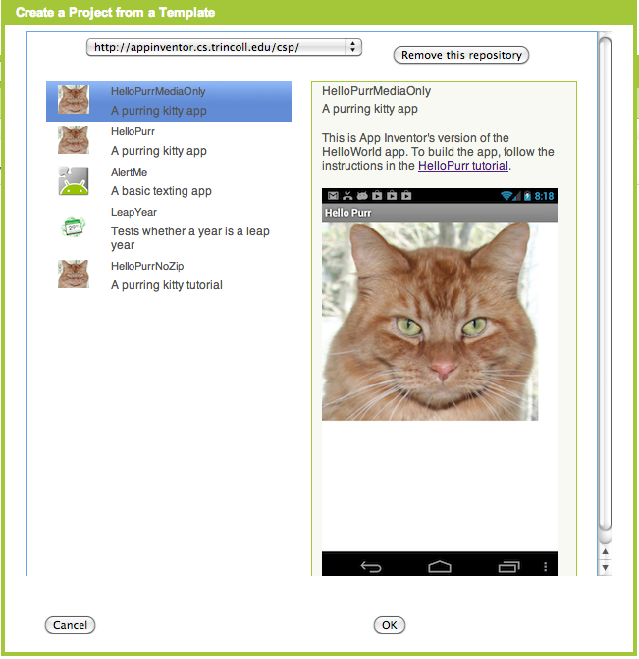

1. From the drop down menu, select *Add a New Template Library URL*
2. Type (do not copy and paste): *http://appinventor.cs.trincoll.edu/csp/week1/*
3. Click the ‘OK’ button.
4. Choose the *TestApp* template. **NOTE:** There is a link to this document in the description of the template. In the future, you can open the template you want to work on in App Inventor and then access the instructions/tutorial for that template by clicking the link.
5. Click the ‘OK’ button. This will open a completed project in App Inventor.

# Test App

When the project opens, you will be viewing the *Designer*. Take a moment to look at what is on your screen. Notice that this simple app contains a two labels for displaying text, an image, and a sound component. Now, switch to the *Blocks Editor* by clicking on Blocks in the top right-hand corner of your window.

The Blocks Editor is where all the coding happens. Take a moment to look at what is on your screen. Notice that this simple app contains colored blocks that are connect liked puzzle pieces. The particular blocks that are connected now will work together to display a congratulatory message on your screen and play a sound. In the next lesson, you will learn how to navigate through the different views, what each view is specifically for, how to design an app, and how to program an app. You are on your way to becoming a programmer!

# Running the App on the Phone (or Tablet)

Did you remember to set up your device? If yes, continue. If not, follow these [setup instructions](https://docs.google.com/document/d/1UYsspfd9zFUcqJNsBuEMyMx7HLl62L_lDPk7oHpjUhY/edit?usp=sharing) and come back to continue.

1. Start the the *MIT NewBlocks Companion* app on your phone or tablet.
2. In App Inventor, click Connect and then select AI Companion. This will display a 6-letter code both as a barcode and as plain text.

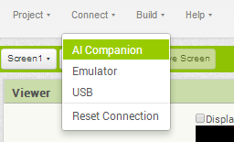

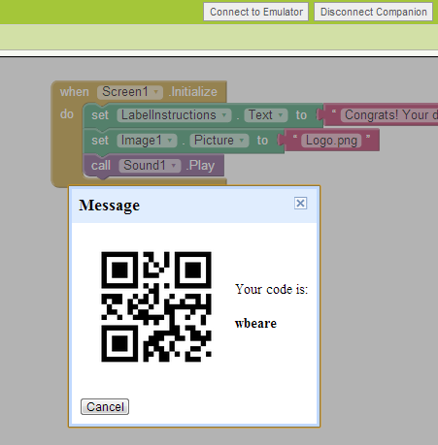

1. On the companion app, either type in the 6-letter code and click the “Connect to App Inventor” button or scan the barcode.

If everything is configured properly, you should see the Test app on your phone. You should see a message and an image of an Android. You should also hear a round of applause for your great work! Before closing the app, show the instructor your properly configured device with the Test App running on it.